**A Level Business Activities for new Sixth Formers**

**Topic 1: Globalisation**

One of the topics you will cover in your second year of A Level is **globalisation.**

To prepare for this section of the course, please complete the following activities.

**TASK 1: RESEARCH**

1. 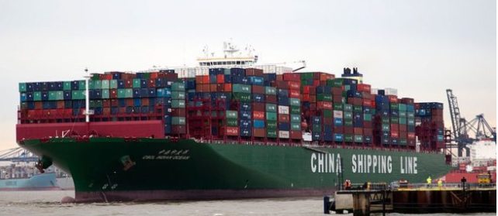Read the following article about how Covid-19 may impact globalisation [here](https://www.bbc.co.uk/news/business-52104978)
2. Consider what the term ‘**globalisation’** means and think about what may cause an increase in globalisation.
3. Further reading around how Covid-19 may impact globalisation can be found [here.](https://observador.pt/opiniao/the-end-of-globalisation/)
4. https://www.theguardian.com/world/2020/apr/28/face-masks-coveted-commodity-coronavirus-pandemic

**TASK 2: MARKETING MATHS & CALCULATIONS**

You will need to use mathematical skills in A Level Business. We will teach you the calculations you need to know but, in the meantime, you could start to develop an understanding of the calculations for market growth and market share.

1. Watch the video clip on Tutor2u about **market growth** <https://www.tutor2u.net/business/reference/market-growth-explained>
2. Watch the video clip on Tutor2u about **market share** share<https://www.tutor2u.net/business/reference/market-share-explained>
3. Using the **calculation for market share**, see if you can calculate the following (HINT: You may need to re-arrange the formula):

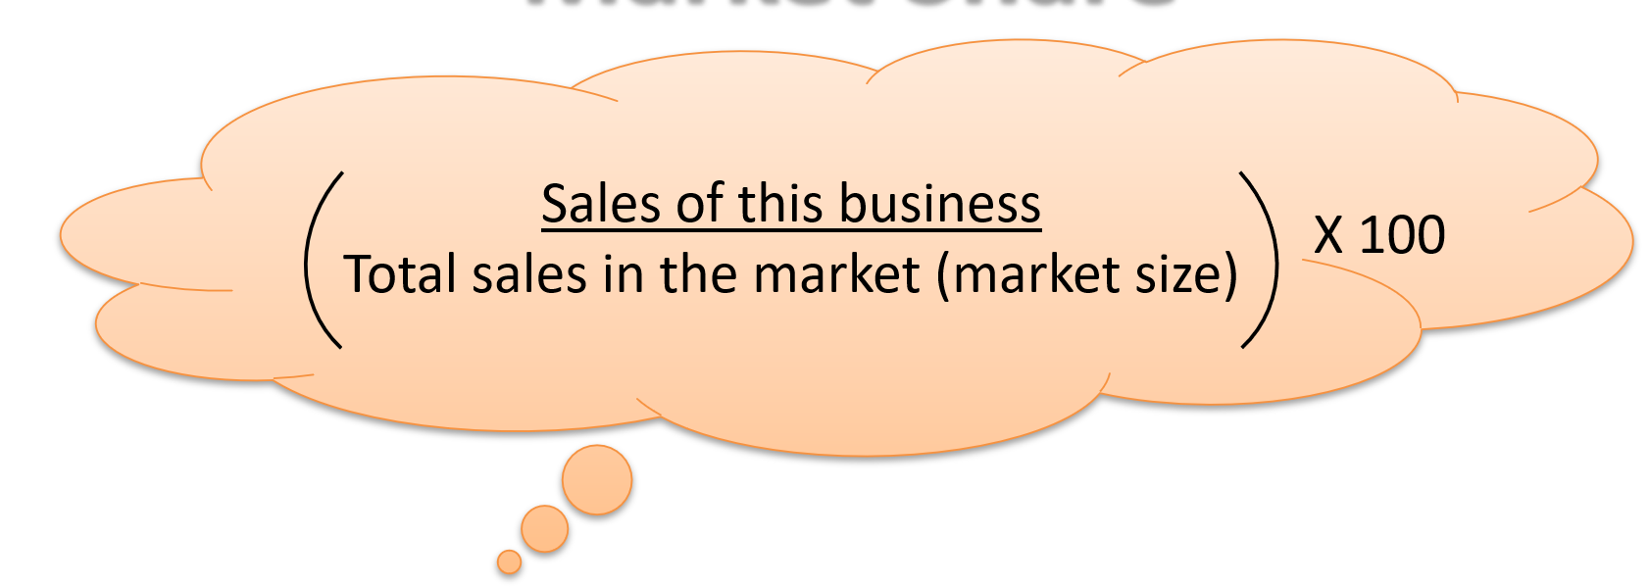

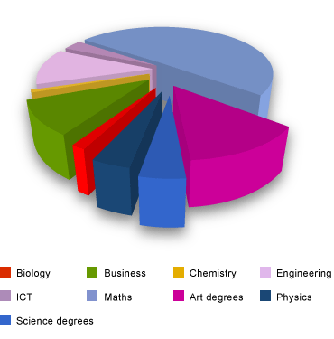

1. A firm has sales worth 703, 842 and the total sales in the market are 2,680,000, what is the firm’s market share?
2. A firm makes 400,553 sales at £8.99 each. The total market is worth 21,100,300. What is the market share of the firm?
3. A firm has a market share of 6% and their sales are 144, 132 units. What is the total market size?
4. A firm has a market share of 5.1% and their sales are 301, 679 units. What is the total market size?
5. A firm has a market share of 4.1% and the total market size is 2.5miilion, what is the value of this firm’s sales.
6. Using your knowledge of market growth, see if you can calculate the following:
7. A market had sales of 1.8bn in 2017 and it grew by 8% in one year, what was the size of the market in 2018?
8. A market had sales of £4.6m in 2018 and it grew by 5.3% in one year, what was the size of the market in 2019?
9. A market had sales of 590,000 in 2018 and 570,000 in 2019. Calculate the percentage growth in the market between 2018 and 2019.
10. A market has sales of £1.25million in 2017 and 1.1 million in 2018. Calculate the percentage growth in the market between 2017 and 2018.

**TASK 3: CASE STUDY CALCULATIONS**

The following information relates to the UK groceries sector in 2014.

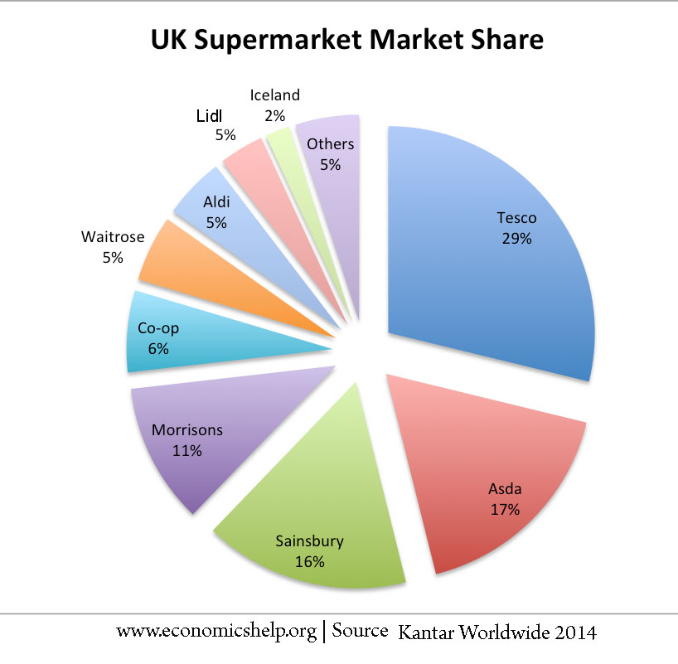

1. Give the formula for calculating market share.
2. Calculate the total market share of the top 4 supermarkets.
3. If the market size for groceries in the UK is valued at £177.5bn. What is the value of Tesco’s sales?
4. Using the information, you have already been given, what would Morrisons’ sales be?



1. Give the formula for calculating market share.
2. Calculate the total market share of the top 4 supermarkets.
3. If the market size for groceries in the UK is valued at £177.5bn. What is the value of Tesco’s sales?
4. Using the information, you have already been given, what would Morrisons’ sales be in value?