CMI372 Music in Context:

C1.2 Analysis of Musical Styles

1950s

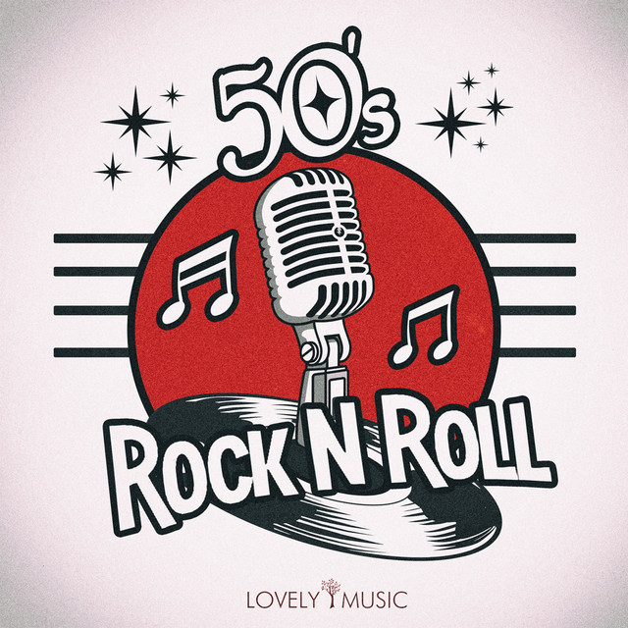
Rock ‘n’ Roll

C1.2 Criteria:
PASS | MERIT | DISTINCTION
Give an explanation of the main musical elements of each style identified in 1.1, with a discussion of the  importance of the elements 1.2a–g, where appropriate, within each style. | Give a clear and detailed explanation of the main musical elements of each style identified in 1.1, with a  thorough discussion of the importance of the elements 1.2a–g, where appropriate, within each style. | Give a comprehensive explanation of the main musical elements of each style identified in 1.1, with an  insightful discussion of the importance of the elements 1.2a–g, where appropriate, within each style.

Contents

Keyword Wordsearch Page 3

Section 1: Introduction to 1950s Rock ‘n’ Roll Pages 4-10
Section 2: Case Study of an Iconic Performer Pages 11-12
Section 3: Roles of Instrumentation Pages 13-16
Section 4: Structure & Form Pages 17-20
Section 5: Harmony & Tonality Pages 21-24
Section 6: Lyrical Content Pages 25-27
Section 7: Technology & Production Values Page 28
Section 8: Analysis of Iconic 1950s Rock ‘n’ Roll Tracks Pages 29-32

Deadline & Submission Information Pages 33-34
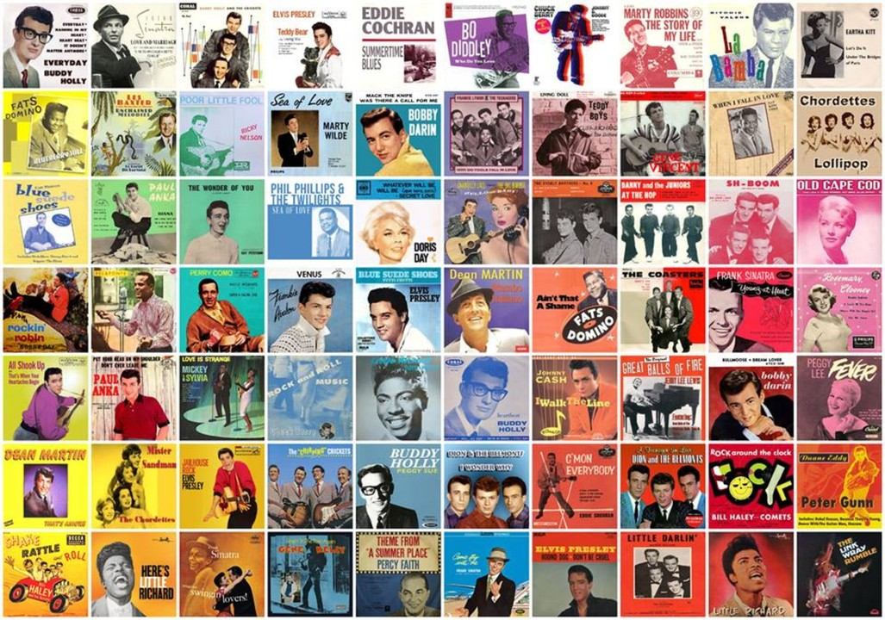

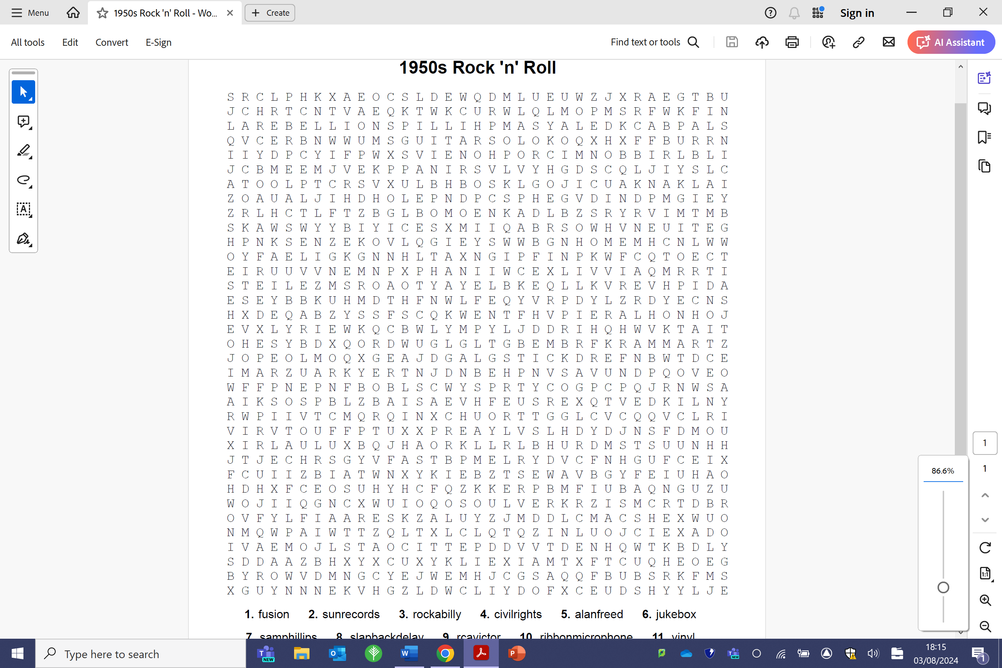
1950s Rock ‘n’ Roll Keywords

FUSION | SUN RECORDS | ROCKABILLY | CIVIL RIGHTS
ALAN FREED | JUKEBOX | SAM PHILLIPS | SLAPBACK DELAY
RCA VICTOR | RIBBON MICROPHONE | VINYL | STEP BALL CHANGE
PETTICOATS | LINDY HOP | JAZZ SHOES | STOP TIME
TWELVE BAR BLUES | FENDER TELECASTER | PRECISION BASS | DANCE HALLS
AMPLIFICATION | GUITAR SOLO | REPETITION | REBELLION
TEENAGE LOVE | SUBCULTURE | CHUCK BERRY | ELVIS PRESLEY
LITTLE RICHARD | BILLY HALEY | BUDDY HOLLY | HORN SECTION
SCAT | WALKING BASS | MINOR PENTATONIC | BLUES SCALE
FAST BPM
SECTION 1:

INTRODUCTION TO 1950s ROCK ‘n’ ROLL
- THE “ROCKABILLY” AESTHETIC
Post-war prosperity had a huge influence on youth culture and music in the 50s, including the subculture fashion and aesthetic.
Q) Discuss what is meant by a SUBCULTURE.
____________________________________________________________________________________________________________________________________________________________________________________________________________________________________________________________________________________________________________________________________________________________________________________________________________________________________________________________________________________________________________________________________________________________________________________________________________________________________________________________________________________________________________________________________________________________________________________________________________________________________________________________________________________________________


Q) Describe the iconic Rockabilly fashion of the 1950s Rock ‘n’ Roll subculture using the image below as a starting point.
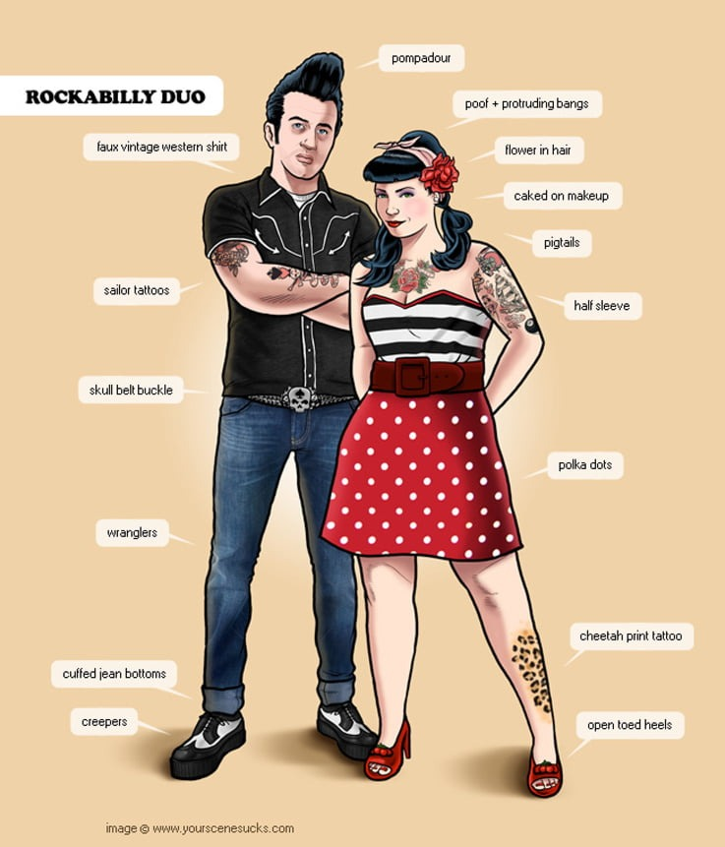
________________________________________________________________________________________________________________________________________________________________________________________________________________________________________________________________________________________________________________________________________________________________________________________________________________________________________________________________________________________________________________________________________________________________________________________________________________________________________________________________________________________________________________________________________________________________________
- SOCIAL CHANGE & YOUTH CULTURE
Alan Freed, a radio DJ from Cleveland, Ohio, noticed that white teenagers, bored with the bland music played on the white radio stations, were getting excited by Rhythm & Blues. Freed started playing it in his programmes, but discreetly called it “Rock ‘n’ Roll”. He quickly became the most successful DJ in the area and a national celebrity.
Q) Who were the main audience and consumers of 1950s Rock ‘n’ Roll music and why did it take off so much as a genre?
________________________________________________________________________________________________________________________________________________________________________________________________________________________________________________________________________________________________________________________________________________________________________________________________________________________________________________________________________________________________________________________________________________________________________________________________________________________________________________________________________________________________________________________________________________________________________

Q) Why did early Rock ‘n’ Roll cause so much controversy?
________________________________________________________________________________________________________________________________________________________________________________________________________________________________________________________________________________________________________________________________________________________________________________________________________________________________________________________________________________________________________________________________________________________________________________________________________________________________________________________________________________________________________________________________________________________________________

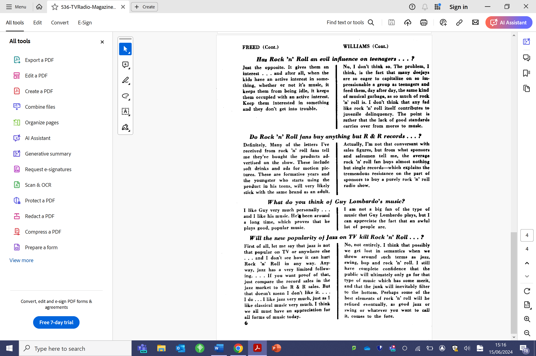
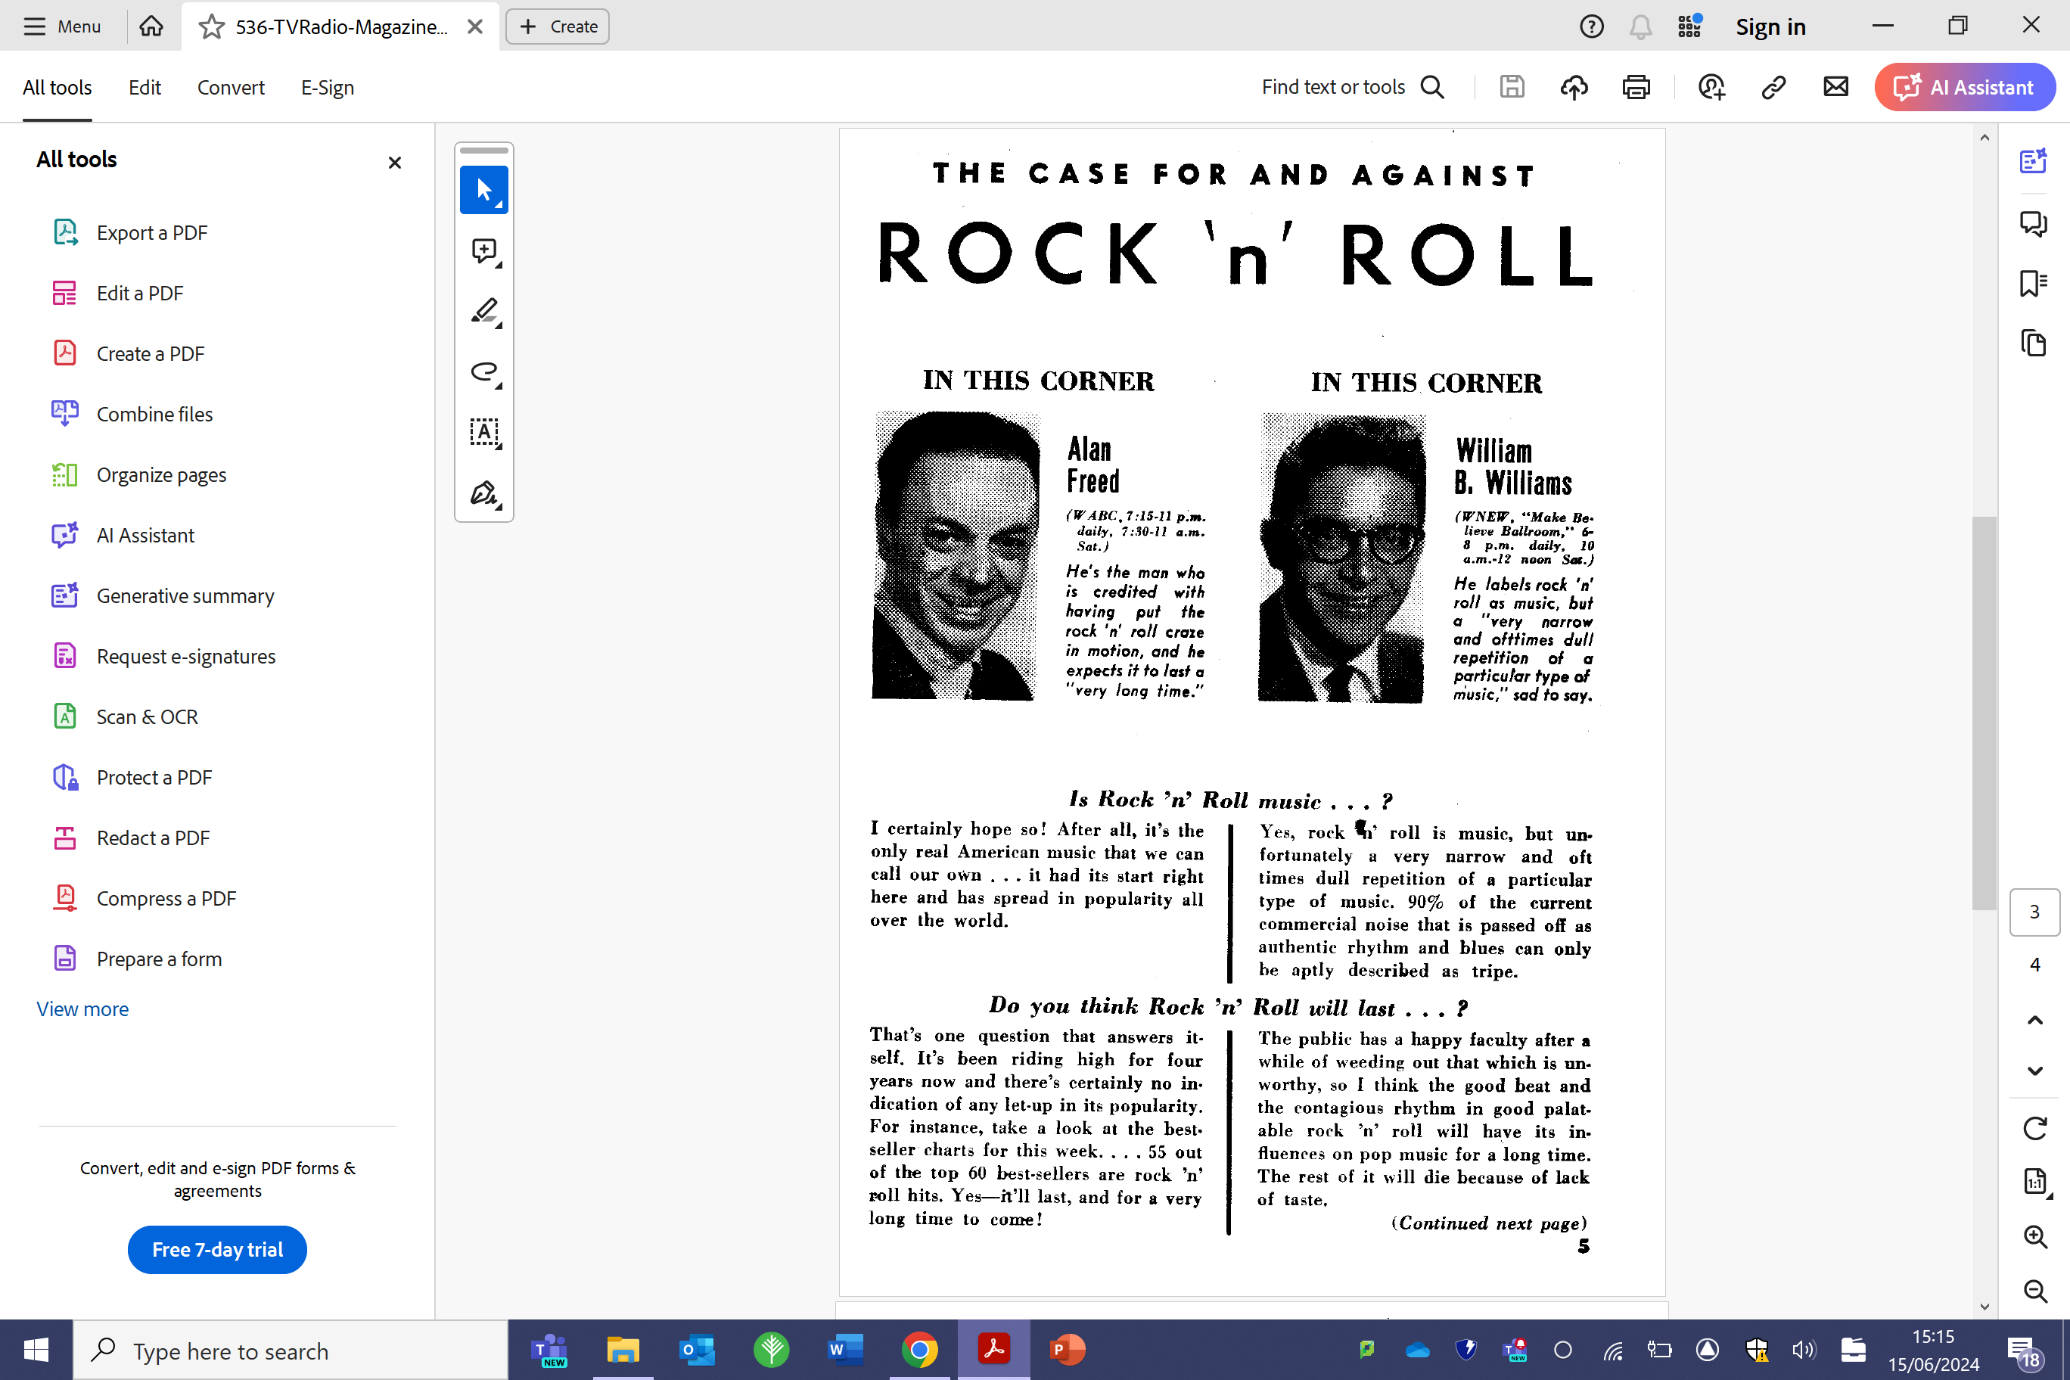

SOURCE 1: “For and Against Rock ‘n’ Roll”

Rock ‘n’ Roll dancing is very athletic and originated from the Lindy Hop. It is danced by both couples and groups.
Q) How did Rock ‘n’ Roll music influence a new dance craze?
________________________________________________________________________________________________________________________________________________________________________________________________________________________________________________________________________________________________________________________________________________________________________________________________________________________________________________________________________________________________________________________________________________________________________________________________________________________________________________________________________________________________________________________________________________________________________
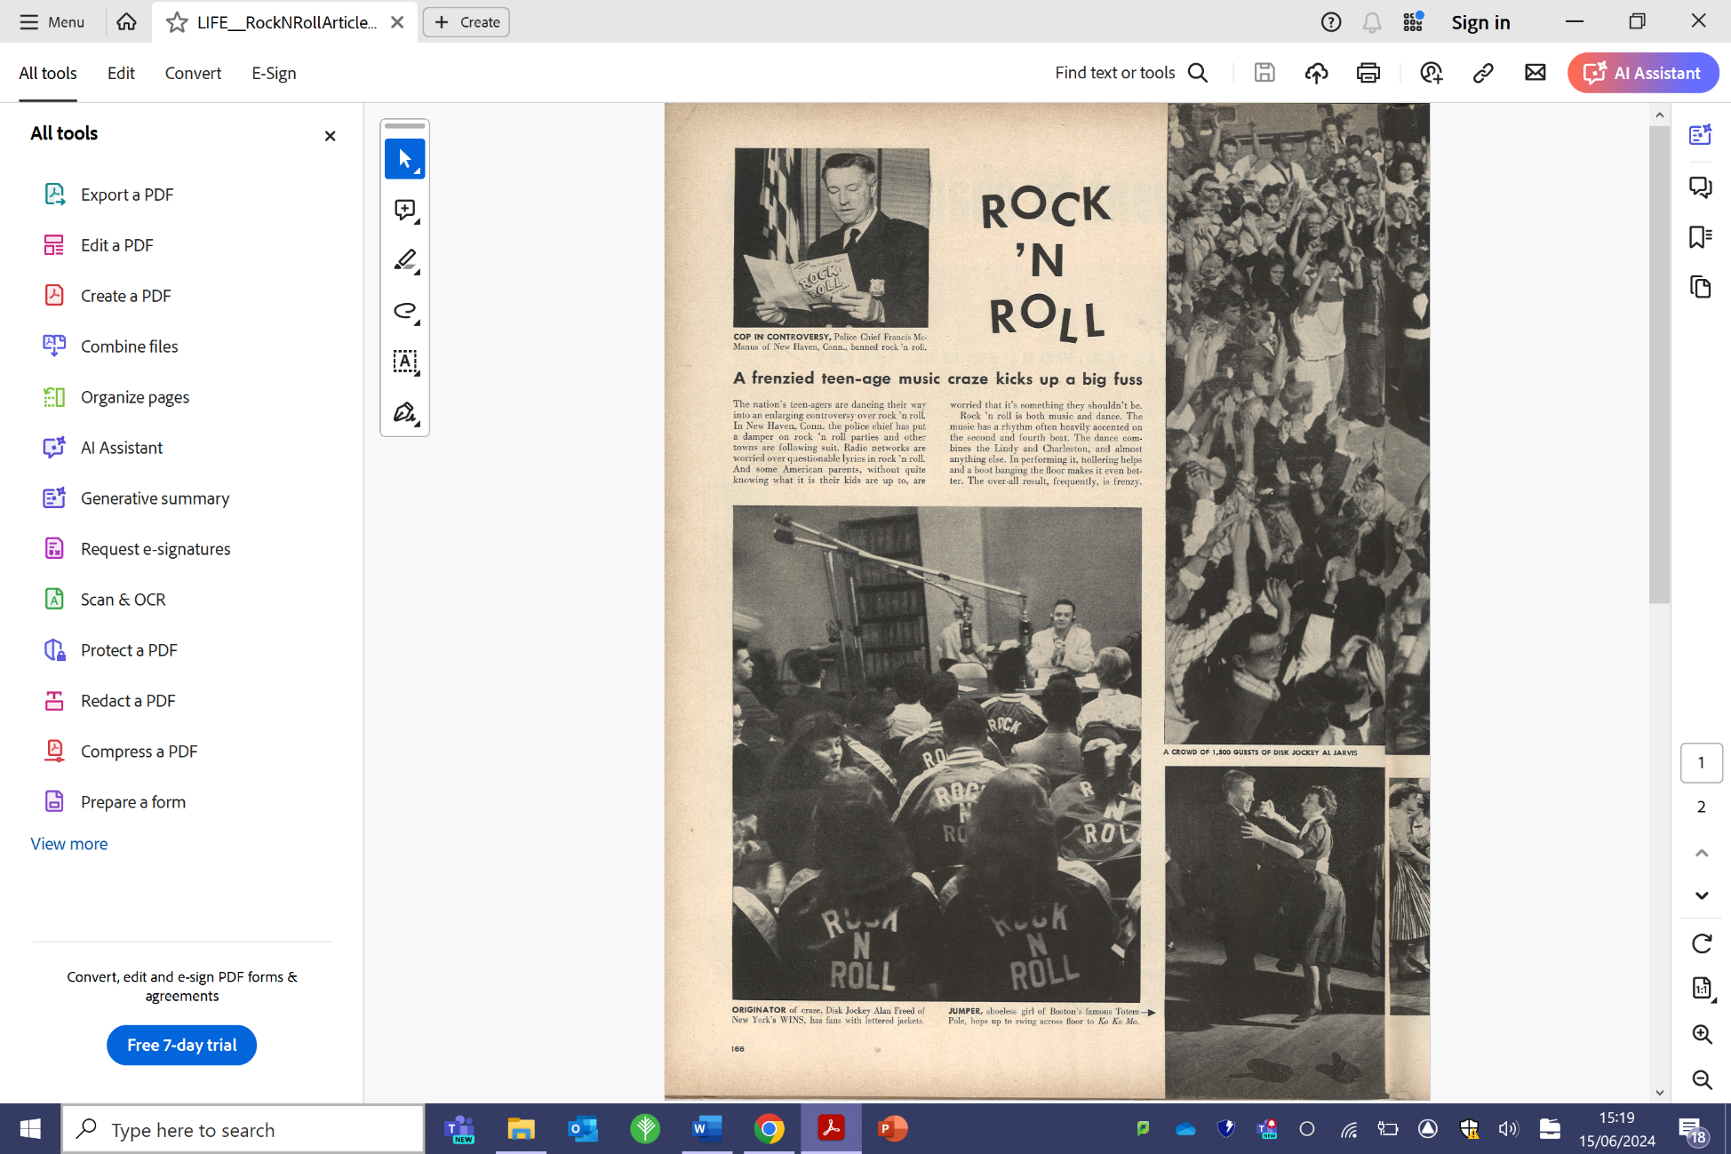
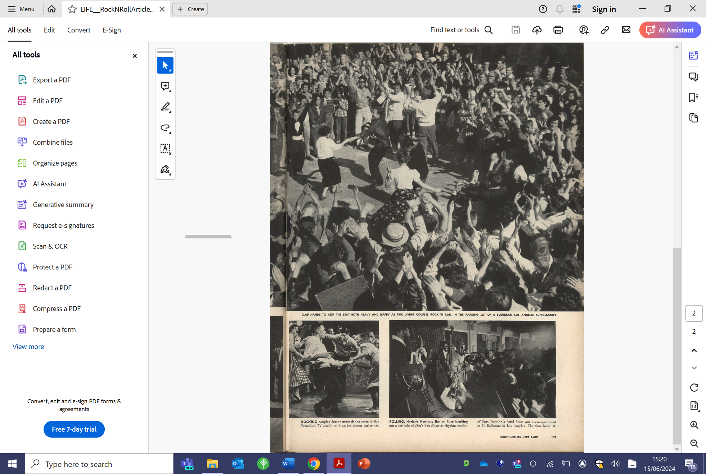

SOURCE 2: “A frenzied teenage music craze”
- JUKEBOXES & RCA VICTOR
Coin-operated jukeboxes were popular in American diners in the 1950s. They held a range of 7-inch 45 rpm records featuring an A/B side. With more and more families enjoying new prosperity after WWII, their teenagers had free time and money to spend on music.
Q) What was so important about the technological advancements within the RCA Victor company in 1949?
________________________________________________________________________________________________________________________________________________________________________________________________________________________________________________________________________________________________________________________________________________________________________________________________________________________________________________________________________________________________________________________________________________________________________________________________________________________________________________________________________________________________________________________________________________________________________
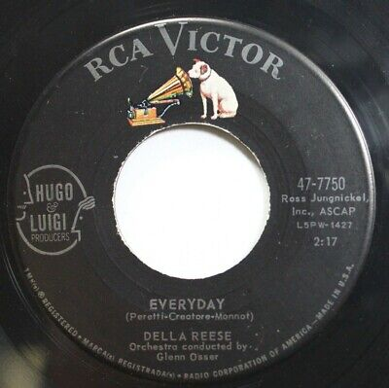

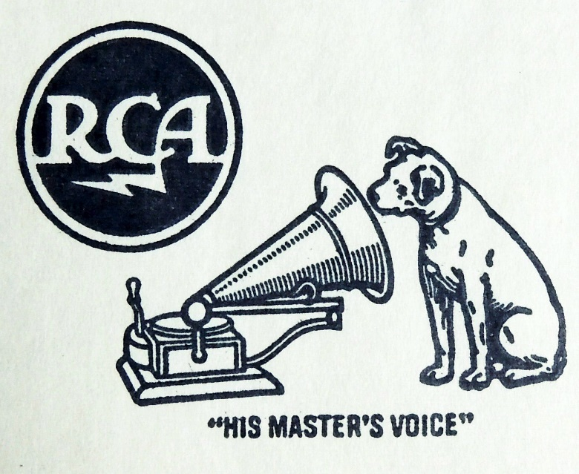

Q) Why were jukeboxes so popular in the 1950s?
____________________________________________________________________________________________________________________________________________________________________________________________________________________________________________________________________________________________________________________________________________________________________________________________________________________________________________________________________________________________________________________________________________________________________________________________________________________________________________________________________________________________________________________________________________________________________________________________________________________________________________________________________________________________________
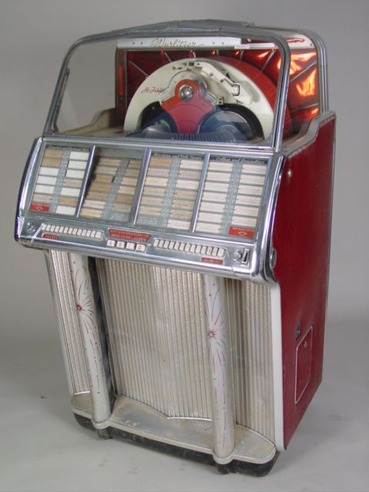
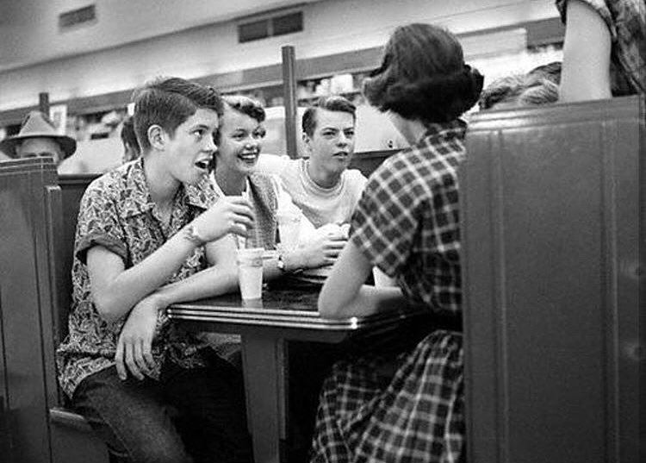
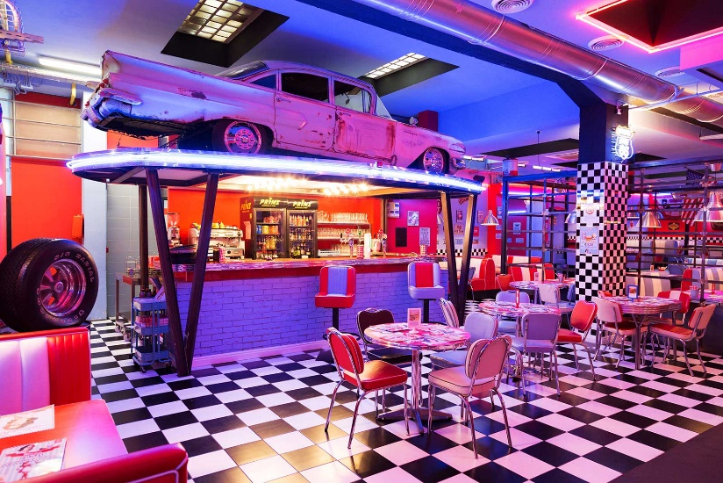

SECTION 2:

CASE STUDY OF AN ICONIC PERFORMER
Q) Research the life and musical career of a significant 1950s Rock ‘n’ Roll music artist (e.g. Elvis Presley, Chuck Berry, Little Richard). This should be an in-depth study covering the following aspects:
- Artist’s musical background
- Major musical output & legacy
- Their influence on the Rock ‘n’ Roll genre and on other musicians
________________________________________________________________________________________________________________________________________________________________________________________________________________________________________________________________________________________________________________________________________________________________________________________________________________________________________________________________________________________________________________________________________________________________________________________________________________________________________________________________________________________________________________________________________________________________________________________________________________________________________________________________________________________________________________________________________________________________________________________________________________________________________________________________________________________________________________________________________________________________________________________________________________________________________________________________________________________________________________________________________________________________________________________________________________________________________________________________________________________________________________________________________________________________________________________________________________________________________________________________________________________________________________________________________________________________________________________________________
________________________________________________________________________________________________________________________________________________________________________________________________________________________________________________________________________________________________________________________________________________________________________________________________________________________________________________________________________________________________________________________________________________________________________________________________________________________________________________________________________________________________________________________________________________________________________________________________________________________________________________________________________________________________________________________________________________________________________________________________________________________________________________________________________________________________________________________________________________________________________________________________________________________________________________________________________________________________________________________________________________________________________________________________________________________________________________________________________________________________________________________________________________________________________________________________________________________________________________________________________________________________________________________________________________________________________________________________________________________________________________________________________________________________________________________________________________________________________________________________________________________________________________________________________________________________________________________________________________________________________________________________________________________________________________________________________________________________________________________________________________________________________________________________________________________________________________________________________________________________________________________________________________________________________________

SECTION 3:

ROLES OF INSTRUMENTATION
- FENDER TELECASTER
The development of the Fender Telecaster electric guitar in the 1950s was a huge turning point for the sound of popular music forever more.
Q) Explore the use and role of the electric guitar in 1950s Rock ‘n’ Roll music.
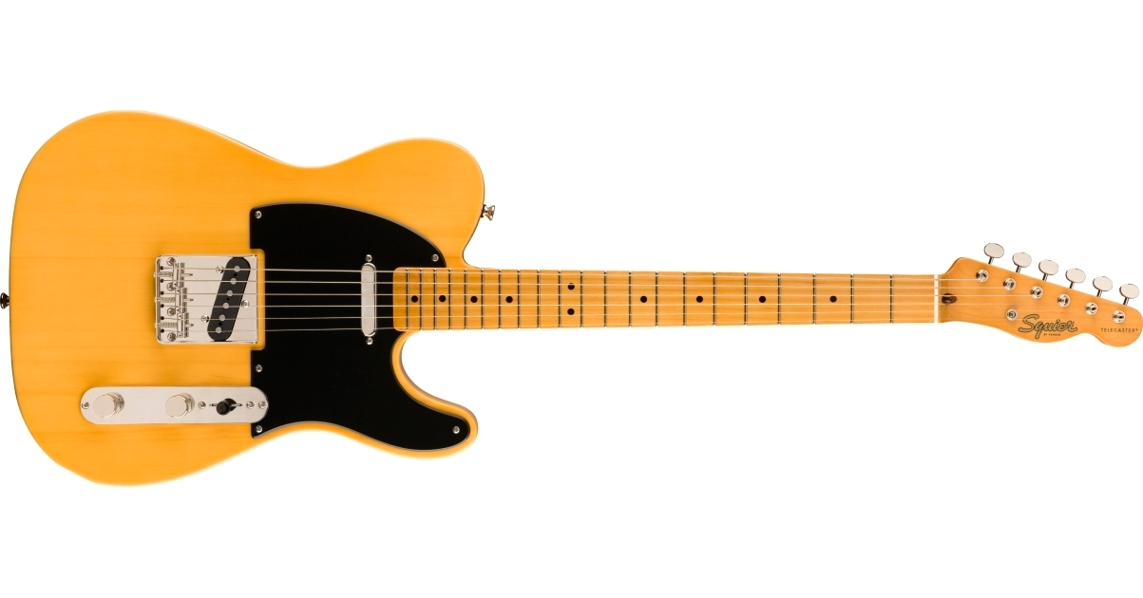
________________________________________________________________________________________________________________________________________________________________________________________________________________________________________________________________________________________________________________________________________________________________________________________________________________________________________________________________________________________________________________________________________________________________________________________________________________________________________________________________________________________________________________________________________________________________________________________________________________________________________________________________________________________________________________________________________________________________________________________________________________________________________________________________________________________________________________________________________________________________________________________________________________________________________________________________________________________

- FENDER PRECISION BASS
The development of the Fender Precision amplified bass guitar in the 1950s forever changed the sound of popular music and helped to shape the format of the standard “rock band” setup as we know it today.
Q) Explore the use and role of the bass guitar in 1950s Rock ‘n’ Roll music.
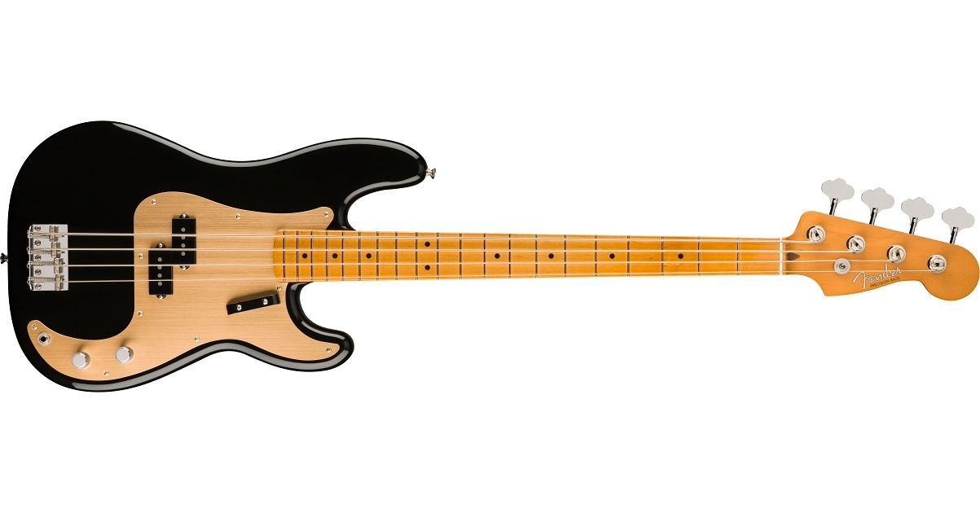
________________________________________________________________________________________________________________________________________________________________________________________________________________________________________________________________________________________________________________________________________________________________________________________________________________________________________________________________________________________________________________________________________________________________________________________________________________________________________________________________________________________________________________________________________________________________________________________________________________________________________________________________________________________________________________________________________________________________________________________________________________________________________________________________________________________________________________________________________________________________________________________________________________________________________________________________________________________

- DRUM KIT
Q) Explore the playing techniques and role of the drum kit in 1950s Rock ‘n’ Roll music.
____________________________________________________________________________________________________________________________________________________________________________________________________________________________________________________________________________________________________________________________________________________________________________________________________________________________________________________________________________________________________________________________________________________________________________________________________________________________________________________________________________________________________________________________________________________________________________________________________________________________________________________________________________________________________

- PIANO
Q) Explore the playing techniques and role of the piano in 1950s Rock ‘n’ Roll music.
____________________________________________________________________________________________________________________________________________________________________________________________________________________________________________________________________________________________________________________________________________________________________________________________________________________________________________________________________________________________________________________________________________________________________________________________________________________________________________________________________________________________________________________________________________________________________________________________________________________________________________________________________________________________________
- HORN SECTION
The horn section in a traditional jazz band in the 1940s is a mixture of woodwind and brass instruments, typically consisting of saxophones, trumpets, and trombones. Occasionally, you would also find clarinets amongst others.
Q) Explore the use and role of the horn section in 1950s Rock ‘n’ Roll music.
________________________________________________________________________________________________________________________________________________________________________________________________________________________________________________________________________________________________________________________________________________________________________________________________________________________________________________________________________________________________________________________________________________________________________________________________________________________________________________________________________________________________________________________________________________________________________

- VOCALS
Q) Explore the vocal delivery and techniques in 1950s Rock ‘n’ Roll music.
________________________________________________________________________________________________________________________________________________________________________________________________________________________________________________________________________________________________________________________________________________________________________________________________________________________________________________________________________________________________________________________________________________________________________________________________________________________________________________________________________________________________________________________________________________________________________

SECTION 4:

STRUCTURE & FORM
- 12-BAR BLUES
The 12-bar blues formula is both a structure and a harmonic scaffold. All 1950s Rock ‘n’ Roll tracks are based around this predictable and highly repetitive pattern and it’s a huge part of what gives the music its iconic and instantly recognisable sound. Each individual section would be built around it and you would typically find the pattern repeated approx. 5 or 6 times in the track.
Here is the 12-bar blues formula:
I | I | I | I
IV | IV | I | I
V | IV | I | I/V
Q) Which cadence(s) is created at the end of each repetition of the 12-bar blues pattern depending on where you are in the track?
__________________________________________________________________________________________________________________________________________________________________________________________________________________________________________________________________________________________________________________________________________________________________________________________________________________________________________________

EXAMPLE: Here is the 12-bar blues in the key of G major –
G | G | G | G
C | C | G | G
D | C | G | G/D
EXERCISES
Q) Map out the chords used in the 12-bar blues in the following Rock ‘n’ Roll tracks, using the keys provided.
a) "Rock Around the Clock" by Bill Haley & His Comets
b) "Johnny B. Goode" by Chuck Berry
Both of these tracks are in the key of A major.

c) "Hound Dog" by Elvis Presley
This track is in the key of C major.

d) "Tutti Frutti" by Little Richard
This track is in the key of F major.

- STOP TIME
Stop time is both a textural and a structural feature of music, prominently found in 1950s Rock ‘n’ Roll and, also, in later genres such as 1980s Heavy Rock. As with many of the features of 50s Rock ‘n’ Roll, the stop time phenomenon can be originally found in 1940s Swing & Big Band jazz.
- How do the early origins of stop time manifest themselves in 1940s jazz tracks such as Duke Ellington’s Koko (1945)?
____________________________________________________________________________________________________________________________________________________________________________________________________________________________________________________________________________________________________________________________________________________________________________________________________________________________________________________________________________________________________________________________________________________________________________________________________________________________________________
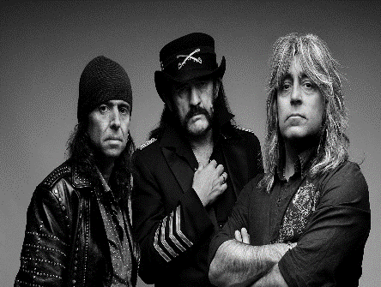
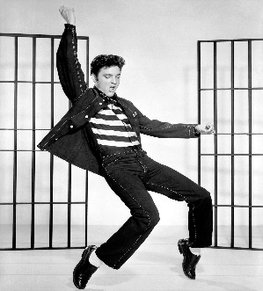
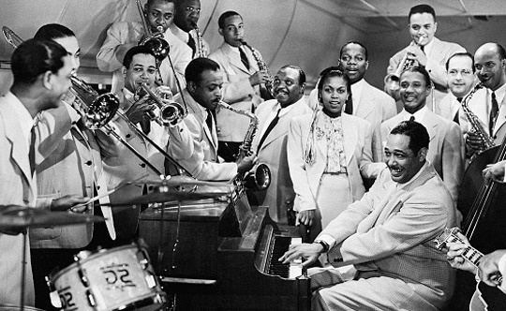

- How does stop time feature in Elvis Presley’s Blue Suede Shoes (1956)?
____________________________________________________________________________________________________________________________________________________________________________________________________________________________________________________________________________________________________________________________________________________________________________________________________________________________________________________________________________________________________________________________________________________________________________________________________________________________________________
- Stop time can be found in Motorhead’s Ace of Spaces (1980). Discuss both the similarities and differences to the stop time found in the 1940s and 1950s.
Similarities | Differences
_________________________________  _________________________________  _________________________________  _________________________________  _________________________________  _________________________________  _________________________________  _________________________________  _________________________________  _________________________________ | _________________________________  _________________________________  _________________________________  _________________________________  _________________________________  _________________________________  _________________________________  _________________________________  _________________________________  _________________________________


SECTION 5:

HARMONY & TONALITY
- BLUES SCALE
The blues scale would typically have been used by electric guitarists, horn players, or pianists to improvise a solo with. It’s a colourful scale that includes three flattened notes, giving it a highly “bluesy” flavour. It provides interest and comfortably fits over the top of the 12-bar blues structure.
Here is the Blues Scale formula:
1 | b3 | 4 | b5 | ♮5 | b7 | 8
The Blues Scale is also very similar to the formula for a minor pentatonic scale, which may also have been used on occasions by soloists. However, it is less colourful as it lacks the interchangeable use of b5 and ♮5.
Here is the Minor Pentatonic Scale formula:
1 | b3 | 4 | 5 | b7 | 8

EXAMPLE: Here is the Blues Scale in the key of G major –
G | Bb | C | Db | D♮ | F | G
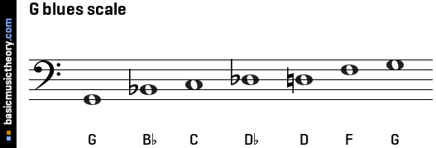

EXERCISES
Q) Map out the Blues Scale in the following Rock ‘n’ Roll tracks, using the keys provided. Write out the note names in the grid and draw out the notation on the stave provided.

a) "Rock Around the Clock" by Bill Haley & His Comets
b) "Johnny B. Goode" by Chuck Berry
Both of these tracks are in the key of A major.
A |  |  |  |  |  | A
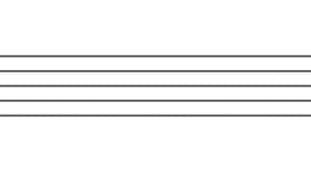

c) "Hound Dog" by Elvis Presley
This track is in the key of C major.
C |  |  |  |  |  | C

d) "Tutti Frutti" by Little Richard
This track is in the key of F major.
F |  |  |  |  |  | F
- WALKING BASS
The walking bass pattern is integral to a successful 1950s Rock ‘n’ Roll track. It is highly melodic and constantly mobile, helping to keep time as a tight rhythm section with the drum kit. It features the “bluesy” flattened 7th note, adding to the flavour of the music.
Here is the Walking Bass formula:
1 | 3 | 5 | 6 | b7 | 6 | 5 | 3 | 1

EXAMPLE: Here is the Walking Bass pattern in the key of G major –
G | B | D | E | F♮ | E | D | B | G
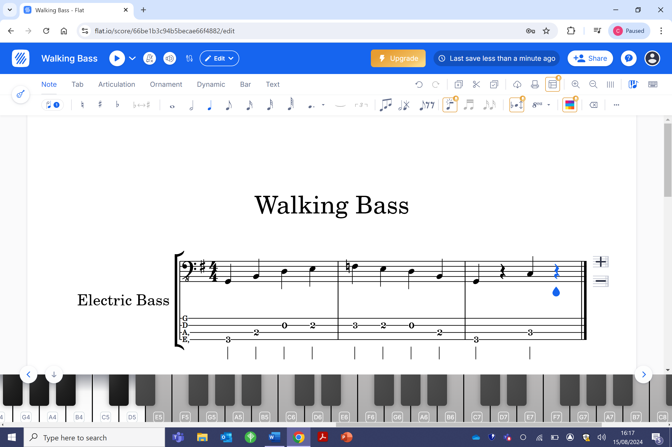

EXERCISES
Q) Map out the walking bass in the following Rock ‘n’ Roll tracks, using the keys provided. Write out the note names in the grid and draw out the notation on the stave provided.
a) "Rock Around the Clock" by Bill Haley & His Comets
b) "Johnny B. Goode" by Chuck Berry
Both of these tracks are in the key of A major.
A |  |  |  |  |  |  |  | A

c) "Hound Dog" by Elvis Presley
This track is in the key of C major.
C |  |  |  |  |  |  |  | C

d) "Tutti Frutti" by Little Richard
This track is in the key of F major.
F |  |  |  |  |  |  |  | F

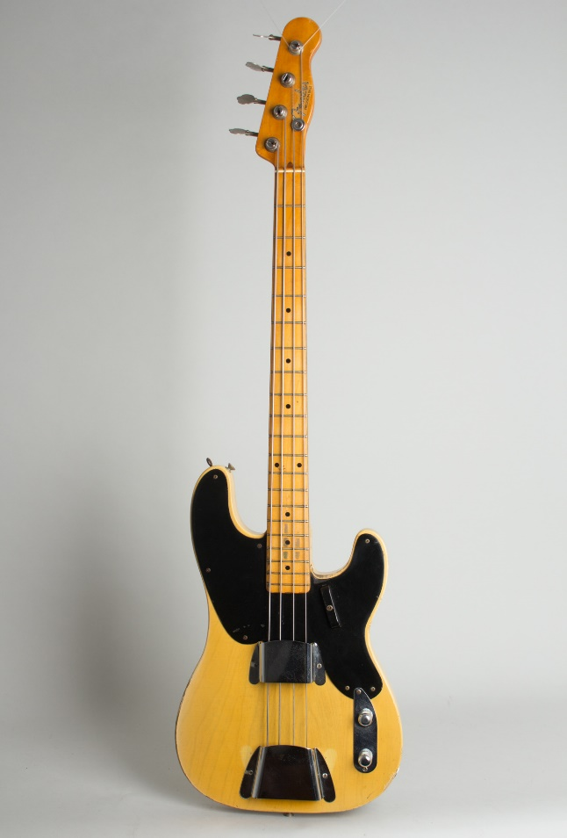
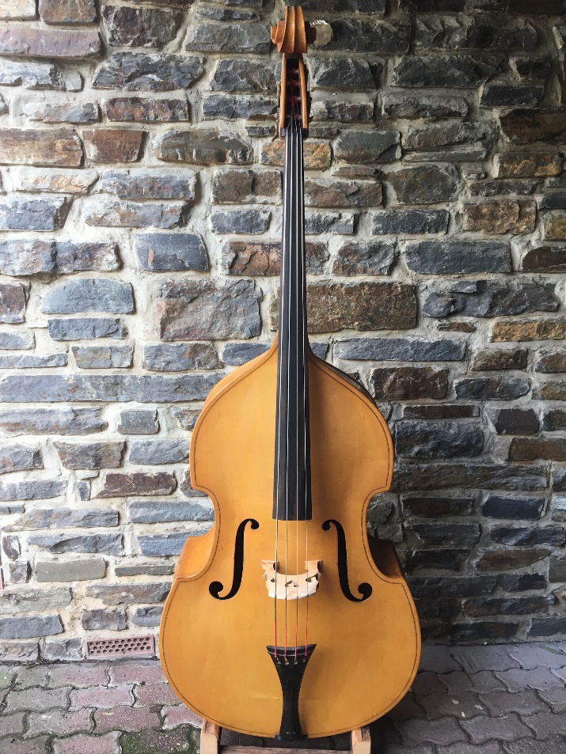

SECTION 6: LYRICAL CONTENT
Common themes of 1950s Rock ‘n’ Roll lyrics include rebellion, teenage love, and freedom.
Q) Explore how the lyrics of the following three songs reflect the social and cultural context of the 1950s.
a) Jailhouse Rock by Elvis Presley (1957)
________________________________________________________________________________________________________________________________________________________________________________________________________________________________________________________________________________________________________________________________________________________________________________________________________________________________________________________________________________________________________________________________________________________________________________________________________________________________________________________________________________________________________________________________________________________________________________________________
[Chorus]  Let's rock, everybody, let's rock  Everybody in the whole cell block  Was dancing to the Jailhouse Rock | [Verse 3]  Number forty-seven said to number three  "You the cutest jailbird I ever did see  I sure would be delighted with your company  Come on and do the Jailhouse Rock with me"
[Verse1]  The warden threw a party in the county jail  The prison band was there, they began to wail  The band was jumping, and the joint began to swing  You shoulda heard those locked-out jailbirds sing | [Verse 4]  Sad Sack was sitting on a block of stone  Way over in the corner weeping all alone  The warden said, "Hey, buddy, don't you be no square  You can't find a partner, use a wooden chair"
[Verse2]  Spider Murphy played the tenor saxophone  Little Joe was blowing on the slide trombone  The drummer boy from Illinois went crash, boom, bang  The whole rhythm section was the Purple Gang | [Verse 5]  Shifty Henry said to Bugs, "For Heaven's sake  No one's looking, now's our chance to make a break"  Bugsy turned to Shifty, and he said, "Nix nix  I wanna stick around a while and get my kicks."
b) Tutti Frutti by Little Richard (1957)
________________________________________________________________________________________________________________________________________________________________________________________________________________________________________________________________________________________________________________________________________________________________________________________________________________________________________________________________________________________________________________________________________________________________________________________________________________________________________________________________________________________________________________________________________________________________________________________________

[Chorus]  Whop bop b-luma b-lop bam bom  Tutti frutti, oh rooty  Tutti frutti, oh rooty  Tutti frutti, oh rooty  Tutti frutti, oh rooty  Tutti frutti, oh rooty  A wop bop b-luma b-lop bam bom | [Verse 2]  Got a girl named Daisy  She almost drives me crazy  Got a girl named Daisy  She almost drives me crazy  She knows how to love me, yes, indeed  Boy, you don't know what she do to me
[Verse 1]  I got a girl named Sue  She knows just what to do  I got a girl named Sue  She knows just what to do  She rocks to the east, she rocks to the west  But she's the girl that I love best | [Verse 3]  Got a girl named Daisy  She almost drives me crazy  Got a girl named Daisy  She almost drives me crazy  She knows how to love me, yes, indeed  Boy, you don't know what she do to me

c) Peggy Sue by Buddy Holly & The Crickets (1956)
________________________________________________________________________________________________________________________________________________________________________________________________________________________________________________________________________________________________________________________________________________________________________________________________________________________________________________________________________________________________________________________________________________________________________________________________________________________________________________________________________________________________________________________________________________________________________________________________

[Verse 1]  If you knew Peggy Sue  Then you'd know why I feel blue  Without Peggy, my Peggy Sue  Oh well I love you gal, yes, I love you Peggy Sue | [Verse 3]  Peggy Sue, Peggy Sue  Pretty, pretty, pretty, pretty Peggy Sue  Oh Peggy, my Peggy Sue  Oh well I love you gal, and I need you Peggy Sue
[Verse 2]  Peggy Sue, Peggy Sue  Oh how my heart yearns for you  Oh Peggy, my Peggy Sue  Oh well I love you gal, yes, I love you Peggy Sue | [Verse 4]  I love you, Peggy Sue, with a love so rare and true  Oh Peggy, my Peggy Sue  Well I love you gal, I want you Peggy Sue
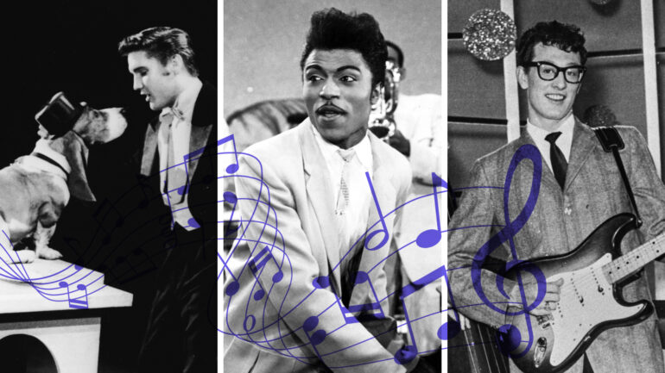

SECTION 7:

TECHNOLOGY & PRODUCTION VALUES
Q) How did technology impact music production during the 1950s?
a) SLAPBACK DELAY
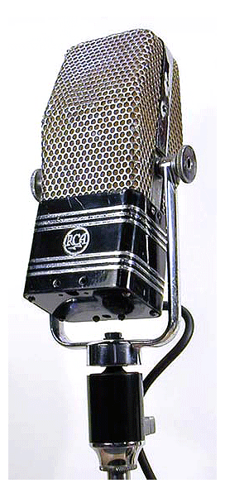
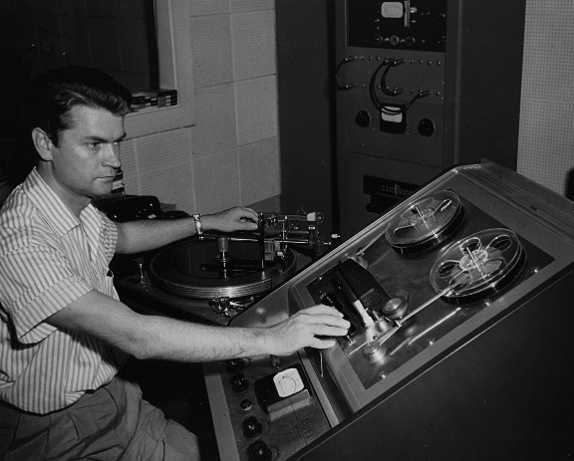
________________________________________________________________________________________________________________________________________________________________________________________________________________________________________________________________________________________________________________________________________________________________________________________________________________________________________________________________________________________________________________________________________________________________________________________________________________________________________________________________

b) RCA VICTOR RIBBON MICROPHONE
________________________________________________________________________________________________________________________________________________________________________________________________________________________________________________________________________________________________________________________________________________________________________________________________________________________________________________________________________________________________________________________________________________________________________________________________________________________________________________________________

SECTION 8: ANALYSIS OF ICONIC 1950s ROCK ‘n’ ROLL TRACKS
Summarise the following songs into a concise track analysis, using a variety of musical terminology.
1. "Rock Around the Clock" by Bill Haley & His Comets
Harmony & Tonality: Key & Chords
__________________________________________________________________
__________________________________________________________________

Lyrical Content
__________________________________________________________________
__________________________________________________________________

Instrumentation & Vocal Delivery
__________________________________________________________________
__________________________________________________________________

Structure, Length & BPM
__________________________________________________________________
__________________________________________________________________

Any Other Musical Features
__________________________________________________________________

2. "Johnny B. Goode" by Chuck Berry
Harmony & Tonality: Key & Chords
__________________________________________________________________
__________________________________________________________________

Lyrical Content
__________________________________________________________________
__________________________________________________________________

Instrumentation & Vocal Delivery
__________________________________________________________________
__________________________________________________________________

Structure, Length & BPM
__________________________________________________________________
__________________________________________________________________

Any Other Musical Features
__________________________________________________________________
__________________________________________________________________

3. "Hound Dog" by Elvis Presley
Harmony & Tonality: Key & Chords
__________________________________________________________________
__________________________________________________________________

Lyrical Content
__________________________________________________________________
__________________________________________________________________

Instrumentation & Vocal Delivery
__________________________________________________________________
__________________________________________________________________

Structure, Length & BPM
__________________________________________________________________
__________________________________________________________________

Any Other Musical Features
__________________________________________________________________
__________________________________________________________________

4. "Tutti Frutti" by Little Richard
Harmony & Tonality: Key & Chords
__________________________________________________________________
__________________________________________________________________

Lyrical Content
__________________________________________________________________
__________________________________________________________________

Instrumentation & Vocal Delivery
__________________________________________________________________
__________________________________________________________________

Structure, Length & BPM
__________________________________________________________________
__________________________________________________________________

Any Other Musical Features
__________________________________________________________________
__________________________________________________________________



FINAL DEADLINE

Thursday 31st October @ 4:00pm

How Should I Present My Work?
You can always choose to present your work in a way that makes the most sense to you. This could be through:
- Handwritten or typed documents
- Scrapbook collages.
- A series of vlogs.
- Audio and/or video files.
- A mixture of all of the above!

How Do I Submit My Work?
Submit and upload your work to either:
- Teams Assignment (digital upload)
- YouTube Channel (audio/video files)
- Homework Box in CB06 (physical documents)

Important to Note
- You must meet the final deadline for this assignment as specified, as well as any smaller interim deadlines that may be set by your teacher.
- Any extensions must be sought in advance of the deadline and must be for a genuine reason.
- Support is always available for all tasks on a 1:1 basis upon request with either Carisse Rooke or Simon Larner.

