A Guide to Using Microsoft Teams

Accessing MS Teams
There are two main ways of accessing MS Teams – through a web browser (e.g. Chrome, Firefox or Explorer – it is currently not supported by Safari), or by downloading MS Teams.
The following steps explain what to do if you are accessing Teams by either of these means.

Teams in a Web Browser
First, if you are not signed in already, go to Microsoft Office 365 log in page: https://www.office.com/
Click Sign In – you will need to enter your King’s email address, which should then take you to the sign in page – sign in using your school username and password.
You will then be asked whether you wish to stay signed in (you may wish to do so if you will be using your device regularly).
You should now have access to your MS Office home page – from here you can access all files that are saved in your OneDrive (ie online storage), as well as online versions of PowerPoint, Forms, Excel, Word and Outlook.

If it is not immediately visible, click on All Apps to bring up Teams, however it is normally on the main list.
Click on Teams and it will open in a new tab on your browser – you should be automatically signed in and it will take you to your home teams page – ie all Teams of which you are a member. These teams are your classes.
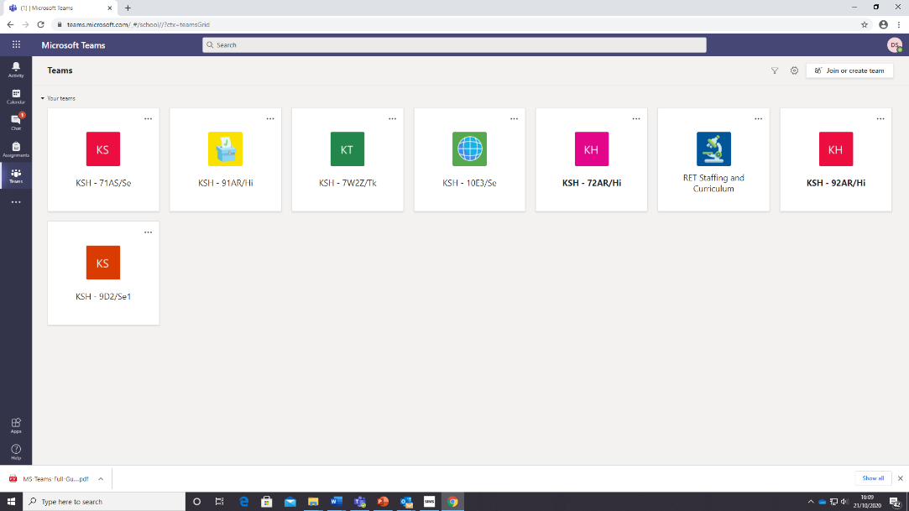

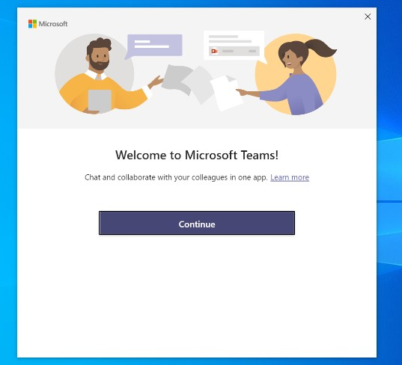
Teams in the App

If you would

like to use the desktop version of MS Teams, which
offers slightly more functionality
, you will need to download this
from
https://teams.microsoft.com/download
s

Click on ‘Download Teams’. Click the downloaded file to launch it
–

this should bring up the desktop app.

Click ‘continue’ and sign in using your King’s email address.

This will take you t
o the login page
–

log in using your
King’s details

Once you have signed in, you can then access the full desktop
version of Teams.
It will automatically open to your
Teams

tab ie a list of all Team
groups of which you are currently a member.

Teams on your Phone
You can also download and use teams on your phone. You can then access lessons and resources on the phone, write your work on paper or in your book and then upload photos of your work.
In this way you can participate in the lesson without the need for a laptop.
Just find it in the Apple or Google Play store. The app is free and you sign in with your King’s credentials as above.

Using MS Teams
MS Teams is where we will teach the lessons and set and collect in work. All of these can be done through the web browser version of Teams and the desktop app. The screenshots below will be of the desktop app.
In your calendar you should be able to see your lessons. When you click on your teams you can join a meeting, see your assignments and leave a message for your teacher

Joining a class
If you can’t see your class in your calendar. Click on the class team and join a
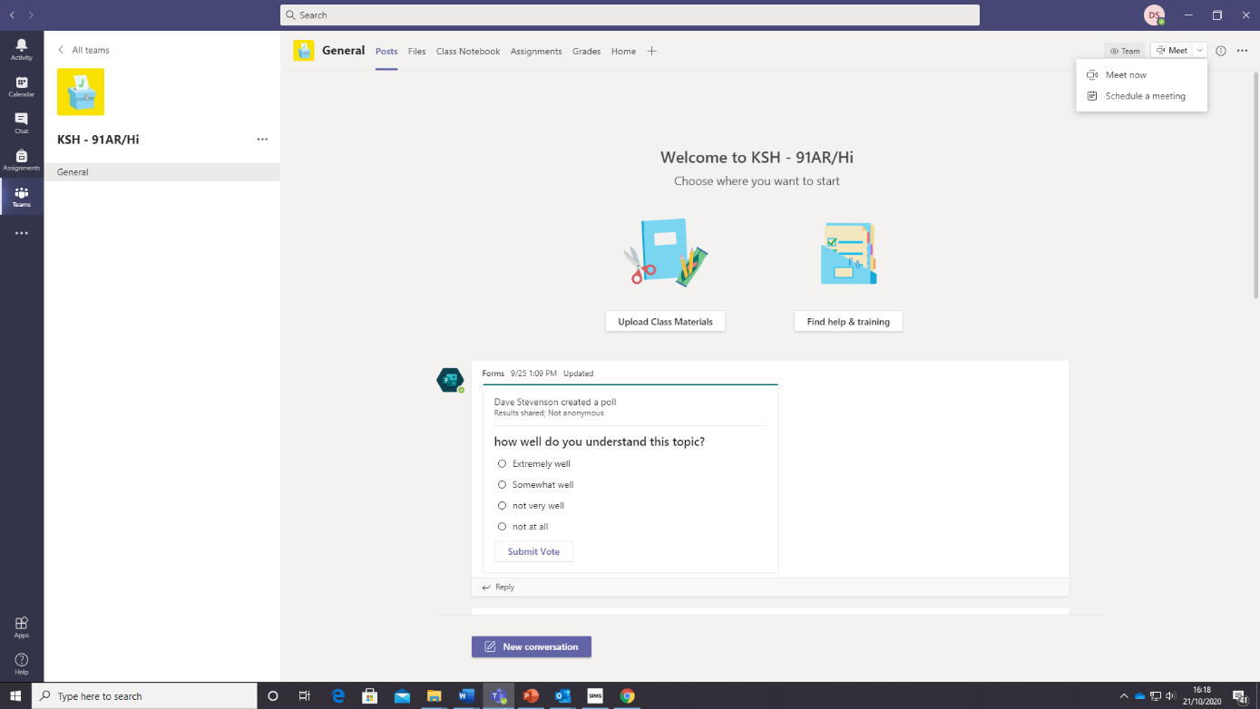
Meeting when it is time for your lesson.

Seeing your work
If you click on assignments the work for your lesson should be there. You can upload your work for your teacher to mark. This can be a photo of your work if you have done it on paper.

