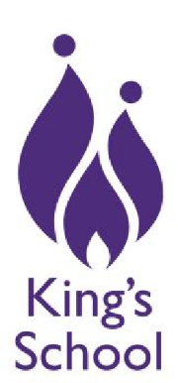
King’s School
Hangleton Way
Hove
BN3 8BN

01273 840004
admin@kingsschoolhove.org.uk www.kingsschoolhove.org.uk

02 June 2026

Good morning all
Please find below a link to join the University of Brighton open days.

https://www.brighton.ac.uk/studying-here/visit-us/ug-campus-open-days
