[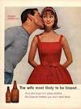](http://www.google.co.uk/url?q=http://www.artflakes.com/en/products/1950s-usa-5&sa=U&ei=IK0yU5_hH-T17Ab0ooCQBw&ved=0CD4Q9QEwCA&usg=AFQjCNFAcWL1crPFZA7zy3dfpQ4DuUan7w)[](http://www.google.co.uk/url?q=http://commons.wikimedia.org/wiki/File:US_Flag_Backlit.jpg&sa=U&ei=C60yU_WjB8eA7QbQqIG4AQ&ved=0CDIQ9QEwAg&usg=AFQjCNECnooUYQQmoy2aHotrAuja8XCQ8Q)**THE 1950s**

**TASK 1: Look at the sources and make notes under the column headings about what the sources tell us about 1950s America**

|  |  |
| --- | --- |
| Source | What does it tell us about 1950s America? Why did the economy boom in the 1950s? |
| SOURCE 1: The birth rate 1940-64 |  |
| SOURCE 2: Car ownership |  |
| Source 3: GNP per capita income, 1940-65 |  |
| [Cadillac Sedan (Orange Julep '10).jpg](http://en.wikipedia.org/wiki/File:Cadillac_Sedan_(Orange_Julep_'10).jpg)  Source 4: a 1953 Cadillac |  |
| http://www.kingsacademy.com/mhodges/03_The-World-since-1900/09_The-Cold-War/pictures/the-prime-TV-audience-in-America_1950s.jpg  Source 5: The 1950s home |  |
| [LevittownPA.jpg](http://en.wikipedia.org/wiki/File:LevittownPA.jpg)  Source 6: An aerial view of Levittown, Pennsylvania |  |

**TASK 2: Look at the statements below-write them onto your diagram to explain the causes and consequences of the boom in 1950s America.**

|  |  |  |  |
| --- | --- | --- | --- |
| It became a vibrant economy, based largely on consumer goods. | The construction industry received a boost as the building of suburbs became more popular-many built using the Levitt and Sons model. | By 1950 there were 40 million cars on the roads of the USA. | In 1947 despite possessing only 7% of the world’s population, the USA produced half the world’s manufactured goods |
| Its military and diplomatic position reflected its strength-number one! | Giant shopping malls and supermarkets made their appearance as a key component in the American way of life. | The curse of the 1930s, unemployment, had all but disappeared. | 20% of families lived below the poverty line-there was still deprivation |
| Technology was given a boost during World Wear Two with high levels of investment. There were consumer spin offs such as the Polaroid camera and the LP player. | Due to low unemployment levels there was a lot less need for social welfare provision and taxation levels could be lower. | By the end of the 1950s over 30% of Americans lived in the suburbs. | By the end of the 1940s the average American enjoyed an income fifteen times greater than the average European |
| The New Deal helped by increasing security for all groups | The baby boom was a cause and consequence of incredible prosperity. | In 1952, Americans spent $225m on chewing gum and $23m on mouthwash | After Taft-Hartley, unions and employers tended to work together. Industrial relations were good on the whole. |
| In 1948, Charles E Wilson, President of General Motors and Walter Reuther, the head of the United Automobile Workers (UAW) signed a deal. Reuther got job security and wages linked to profits and Wilson got a ‘no strikes’ agreement. | The GI Bill of the Serviceman’s Readjustment Act had the effect of promoting a housing boom. | In 1946 there were 34 million babies born. Between 1946 and 1964, 76.4 million babies were born. | Although Federal expenditure shrank after World War Two (which was inevitable), it was still 36.5 billion in 1948 which shrank the pre-war level of $9.4 billion. |
| With no consumer goods available during World War Two Americans had little opportunity to spend and could only save. By the 1950s this meant Americans could be consumers again. | The baby boom encouraged the development of a dynamic juvenile market. Each infant was thought to be worth $800 to the producers of baby and child products | The growing confrontation with the USSR as the Cold War developed fuelled renewed weapons production and expansion around Seattle, southern California and the Rocky Mountain states. | Poverty stricken sharecroppers gave up their smallholdings and became an industrial workforce. |

EXTENSION 1: Add to your causes and consequences diagram using your own ideas

EXTENSION 2: Colour code your causes and consequences diagram to show hwo causes and consequences relate to different factors:

KEY:

|  |  |
| --- | --- |
|  | FACTOR |
|  | TECHNOLOGY |
|  | BABY BOOM |
|  | UNION HARMONY |
|  | NEW DEAL |
|  | FEDERAL GOVERNMENT  SPENDING |

EXTENSION 3:

What was the most important cause of the boom?____________________________  
_____________________________________________________________________________________________________________________________________________________________________________________________________________________________________________________________________________________________________________________________________________________________________________________________________________________________________________________________________________________

___________________________________________________________________

What was the most important consequence of the boom?______________________   
_____________________________________________________________________________________________________________________________________________________________________________________________________________________________________________________________________________________________________________________________________________________________________________________________________________________________________________________________________________________

___________________________________________________________________

[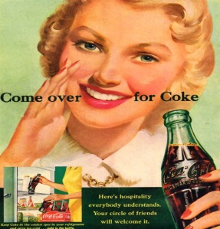](http://www.adbranch.com/coca-cola-magazine-ads-from-1950s/coca-cola_thirst_asks_nothing_more_1951/)

CONSEQUENCES of the 1950s BOOM

CAUSES of the 1950s BOOM

[](http://cdn10.mixrmedia.com/wp-uploads/flauntme/blog/2010/12/marilyn-monroe-1950s.jpg)[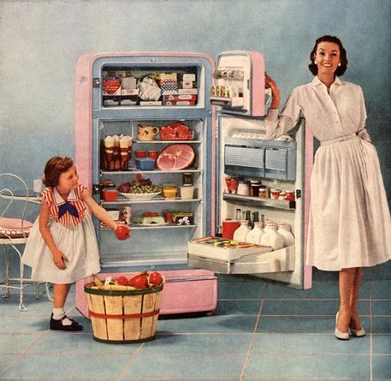](http://www.artflakes.com/en/products/1950s-usa#show-zoom)[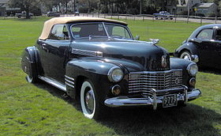](http://en.wikipedia.org/wiki/File:1941_Cadillac_Series_62_convertible_coupe.JPG)

TASK: Write your list of the nine most important causes of the boom on this diamond nine

EXAMPLE A QUESTION 1: The economic boom of the 1950s was largely caused by Federal Government spending. How far do you agree with this view?

|  |  |
| --- | --- |
| It could be argued that federal government spending caused the boom … | It could be argued other factors were responsible for causing the boom … |
|  |  |

EXAMPLE A QUESTION 2: What were the causes of the 1950s economic boom?

TASK: Read through this excerpt from an example answer-explain what is good about the answer and how the answer could be improved-fill in the examiner comments box at the end!

The economic boom of the 1950s was largely caused by Federal Government spending. How far do you agree with this view?

“The 1950s was a period of immense wealth in America where people were paid high wages and living standards were extremely good and the best in the world. This is because America won World War Two and because the American economy was booming. There was a lot of wealth around and many people argue that the 1950s was a great time to be alive.

In some ways the economic boom of the 1950s was caused by the baby boom. This describes how after World War Two the birth rate went up massively in America. In 1946, 34 million babies were born. Apparently. this caused the development of a juvenile market. Each infant was thought to be worth $800 to the producers of baby and child products and so they benefitted from this. But from an economic standpoint the baby boom also produced lots of new workers and lots of new consumers. These baby boomers bought more products as the decade progressed and they also paid things like federal taxes. The 1950s boom could not have happened without the baby boom because it boosted markets like the baby market but also and more importantly it created lots of new workers and consumers as well as tax payers. If the population was falling it would be unlikely that the economic boom would have occurred.

I think a more important reason why the economy boomed in the 1950s was because of union harmony. This is because workers and employers worked together to make the economy boom. In Europe industrial relations could be very fractious but this was not the case in post war America. The Taft Hartley Act took a more harsh approach towards the unions and in any case American workers did not have the same strike ethic of many of their European comrades. Therefore, economic disruption through industrial action was less likely to happen and therefore the economy was more likely to boom.”

What does the student do well?__________________________________________  
_______________________________________________________________________________________________________________________________________________________________________________________________________________________________________________________________________________________________________________________________________________

What could the student do to improve?____________________________________  
_______________________________________________________________________________________________________________________________________________________________________________________________________________________________________________________________________________________________________________________________________________

What level/score would you give this essay?_______________________________